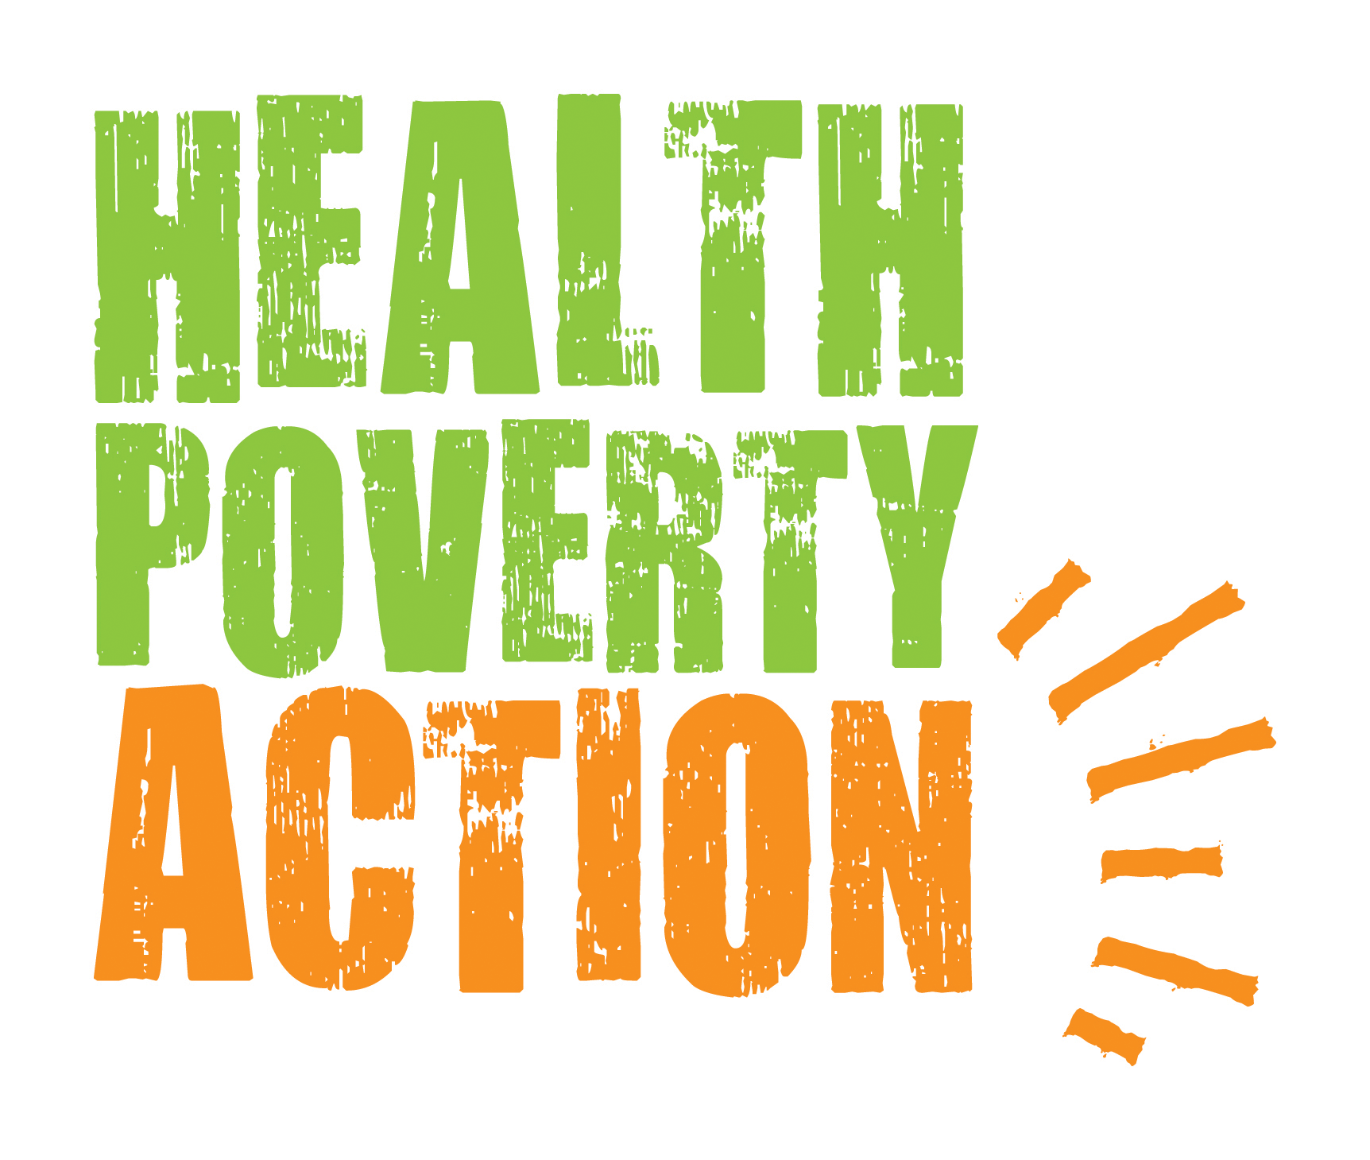

Job Description

Job title: Somaliland Country Director

Reporting to: Head of Programmes, Africa

Responsible for: Sahil Programme Manager, Hargeisa Programme Manager, Burao Programme Manager, National Nutrition Manager, Finance and Administration Officer, and ultimately all staff in the Somaliland office

Base: Hargeisa, Somaliland

Background:

Established in 1984, Health Poverty Action’s (HPA) work has grown to include programmes in 13 countries across Africa, Asia and Latin America (with more currently in development). We always prioritise the poorest and the most marginalised – those not reached by governments and almost everyone else. This has led us to work in some very difficult environments, often providing the only external assistance.

Poverty and ill health are inextricably bound together. Each is both a cause and a consequence of the other. Put positively, this means there is great power in an approach that addresses both of them. Improvements in one yield improvements in the other. This is the approach HPA is committed to. It makes health first and foremost not a medical challenge – though that plays its part – but a fundamental issue of justice and human rights.

Working with communities to build local capacity, HPA’s programmes seek to pioneer new approaches. We take a holistic approach, focusing not just on the health sector but being prepared to do anything we can to help make the biggest possible difference to health. Our programmes attach a high priority to strengthening health systems, supporting safe birthing, prevention of life-threatening diseases such as malaria, TB, HIV, and other dangerous infections and improving communities’ health-seeking behaviour.

HPA programmes also attach great importance to other factors such as nutrition, water and sanitation, income generation, and the social, economic and environmental determinants of health. Our programmes take a rights-based approach, strengthening poor and marginalised communities to advocate on their own behalf.

HPA been working in Somaliland since 1994 and has broadcast a radio programme from Hargeisa since 1999. HPA has, over the years successfully implemented a number of projects supported by the European Commission, FCDO, UNICEF, WFP, UNFPA, Global Fund and other trusts and foundation. For the effective implementation of projects, the Country Director will be expected to oversee all programme activities and processes.

This key post is the most senior post in the country office in Somaliland, and therefore includes representation duties, project, human resources and financial management oversights, and leading and coordinating proposal writing, partnership development and management, and overall leadership of the country programme.

Main Functions of Post:

- Provides overall management for the FCDO funded UNICEF managed Multisectoral drought response (HPD) project implemented in ten selected districts across Sahil, Togdheer, Sool and Awdal regions; the EC (Somaliland Terminating Oppression of women and girls Program II (STOPII) project in Burao and Ainabo districts and the WFP nutrition project Togdheer Burao, Hargeisa, Sheikh and Berbera Districts of Somaliland, ensuring good financial and general administration of projects, staff, finances and assets. The CPM is responsible for the development and management of the country program strategy, planning, organizing, operating, staffing and budgeting, financial and risk management.
- Represents HPA in Somaliland in the promotion of excellent relationships with central and local government departments, international organizations, other NGO’s and in-country donors.
- Maintains good internal communications both with the Head of Africa Programmes and the Programme Mangers, and the central Health Poverty Action office in London.
- Leads and supports programme development and resource mobilisation for Somaliland and Somalia

Responsibilities:

- Provides overall management for the DFID funded Sahil EPHS, the EC EIDHR, STOP and the WFP nutrition project in Maroodi Jeex, Sahil and Togdheer Regions, and the UNFPA supported maternal and newborn health projects in Hargeisa and Burao districts of Somaliland, ensuring good financial and general administration of projects, staff, finances and assets. The CPM is responsible for the development and management of the country program strategy, planning, organizing, operating, staffing and budgeting, financial and risk management.

  - Project Cycle Management
  - Develop and maintain robust management systems and tools to enhance efficiencies and accountability throughout the country programme.
  - Prepare/review a country strategy, annual work plans and budgets in accordance with project proposals
  - Ensure that project activities are implemented and outputs/results produced in accordance with project proposals, budgets, and donor contracts
  - Provide inspiring leadership, management and technical support to staff
  - Respond to and communicate with the Head of Africa Programmes on internal and external influences which affect or have the potential to affect project progress
  - Directly lead and supervise programme managers and ensure that projects are effectively monitored and evaluated
  - Report to the Head of Africa Programmes on the progress and problems of projects in accordance with HPA and donor guidelines

  - Financial Resources and Asset Management
- Oversee the posting of expenses on the Iplicit financial system, ensuring that these comply with and fulfil all HPA requirements including supporting documentations, for submission to the Head office finance department
- Ensure that project expenditure is made and monitored against budgets and in accordance with donor contracts, including due processes and supporting documentation requirements including bank statements, bank reconciliations and review of variances between budgets and expenditures.
- Oversee and monitor proper and timely posting of expenses on the financial system.
- Ensure that efficient office systems are maintained in the projects
- Ensure that all HPA property is maintained, stored safely, and used in accordance with agreed activities, well documented, updated and maintained fixed assets registers, documented maintenances, handovers and disposals.
- Ensure timely requests for transfers of funds from central HPA.
- Ensure timely internal and external audits, response to management letters and follow up of audit recommendations and action points.

  - Human Resource Management
  - Recommend any changes to project staffing and job descriptions on the country team structure to the Africa Head of Programmes
  - Develop and maintain personnel policies and procedures for national staff in line with the relevant national policy concerning labour and employment.
  - Co-ordinate all recruitment, induction, training and performance appraisal of staff
  - Ensure that all Human Resource policies and procedures are followed
- Coach and encourage professional development/skills building of staff
- Promote team-building activities and carry out conflict resolution, as necessary
- Review, monitor, and implement HPA’s safety procedures and security situation, and ensure that staff members are aware of these procedures
- Represent the organisation in meetings taking place in Hargeisa, Nairobi or elsewhere when requested/approved to do so by the Africa Head of Programmes.
- Provide oversight on the compliance of the country and project teams on internal policies including Safeguarding, Data Protection etc.

  - Management and Coordination of HPA’s Field Programme Offices (Sahil, Boroma and Burao)
- Provide technical, management and coordination support to the Sahil, Boroma and Burao Programme Managers
- Provide technical and management support to the National Nutrition Programme Manager in the development and implementation of Nutrition projects with WFP, UNICEF and other donors
- Represent HPA’s Program Managers and projects in meetings held in Hargeisa.

  - Undertake any other duties which might reasonably be requested by the line manager.

- Represent HPA in Somaliland in the promotion of excellent relationships with central and local government departments, international organizations, other NGO’s and in-country donors.

- Attend meetings representing HPA with other agencies or networks in Somaliland
  - Attend meetings relating to Somaliland programming in Nairobi such as donor -government – implementing partners coordination meetings, as agreed with/approved by the Head of Programmes Africa
- Meet with Government representatives, NGO partners, donors and any other relevant stakeholders, in order to develop and maintain excellent relationships, explore new partnerships/synergies, and join hands to influence policy and practice
- Ensures that HPA meets legal requirements in Somaliland
- Liaise with potential in-country donors to explore funding opportunities

- Maintain good internal communications both with the Head of Africa Programmes and the Programme Mangers, and the central Health Poverty Action office in London.

- Maintain communication with the Head of Africa Programmes and advises on developments in the health sector, as well as on social, economic and political developments in Somaliland
  - Promote and facilitate good communication and exchange with and between/among Africa regional office, country office and field project staff

4. Lead and assist in programme development and resource mobilisation for Somaliland and Somalia

- Develop an awareness of health, social, economic and political developments in Somalia and Somaliland
- Identify and recommends to the Head of Africa Programmes new project proposals for HPA in Somaliland and Somalia
- Leads in conducting assessments to determine needs for proposal development
- Meets with potential partners to explore opportunities for partnerships and joint proposals
- Develops project proposals for submission to donors (international)
- Assist in exploring the potential of establishing a local Somaliland NGO for the health communications
- Develop good relationships with the representatives of donors based in Somaliland/Nairobi
- Explore opportunities for carrying out consultancies to increase in-country funding

Person specification:

Essential requirements
At least 5 years experience as a health and/or development programme manager, preferably in Sub-Saharan Africa
- Bachelors’ degree in health-related discipline or social sciences
- Significant proven development programmes experience with governments, INGO, NGOs, related to integrated development and health
- Representational skills, diplomacy and the ability to communicate and negotiate at all levels.

Experience in managing project grant contracts
- Proven skills in human resource management
- Proven skills in Project Cycle Management
- The ability to think and operate strategically, with strong conceptual and analytical skills
- Proven skills in effective networking and collaboration with partners and other stakeholders
- Teambuilding and leadership skills - the ability to communicate effectively, motivate individuals and teams, resolve conflict and promote effective working relationships.
- Relationship builder and communicator with experience leading diverse teams, developing strategies for program excellence, engaging community partners and working closely within the senior leadership team.
- Proven ability to monitor and evaluate field programs and understand the relationship between field and HQ.
- Ability to establish and maintain positive working relationships with others, both internally and externally, to achieve the goals of the organization.
- Foster Teamwork – the ability to work cooperatively and effectively with others to set goals, resolve problems, and make decisions that enhance organizational effectiveness.
- Experience with EU, FCDO (formerly DFID), UN agencies, USAID, Irish Aid etc. funded programs including related rules and regulations including engaging with key stakeholders in the national and international NGO community.
- Outstanding problem solver - Assess problem situations to identify causes, gather and process relevant information, generate possible solutions, and make recommendations and/or resolve the problem.
- Ability to travel to field sites to provide on-site leadership to programs.
- Ability to work both independently and on one’s own initiative.
- Understanding of and commitment to humanitarian principles
- Cultural sensitivity.
- Ability and flexibility to work in stressful and unstable areas
- Excellent written and verbal communication skills – with ability to communicate with tact and diplomacy to manage conflict.
- Proven financial management skills in accounting, budgeting and reporting;
- Computer literacy in Word, Excel, Power Point
- Fluent oral and written English

Desirable requirements
Experience supervising staff operating in multiple field programs across a sub-Saharan country
- Masters degree in health related discipline or social sciences
- Knowledge and understanding of Africa, particularly the sub-Saharan and Horn of Africa
- Proven understanding of how international organizations work
- Experience working in or with hospitals or clinics
- Experience in health education using mass media including radio
- Experience of organising and facilitating participatory discussions
- Ability to understand Somali will be a plus
- Experience of representing an organisation to governments and donors
- Proposal and report writing skills
- Experience of working in Somalia or Somaliland

Terms and Conditions:

From 26,721 GBP salary per annum. The benefits package includes:

• 5% of salary lump sum paid at end of contract in lieu of pension
• £600 living allowance. If you like, you can pay 10$ day / $300 month to be catered for in terms of cooking (3 meals a day), cleaning, laundry, kitchenware, other household essentials)
• Free furnished accommodation
• Pre departure medical clearance and immunizations
• Travel medical insurance coverage
• 25 days annual leave plus up to 12 days of national holidays
• 1 week of Rest & Relaxation (R&R) leave for every 8 weeks of field office. R&R is paid leave
• R&R flights up to $5,000 per year Plus taxi to and from the airport up to 50$ each journey

This in an unaccompanied position.

