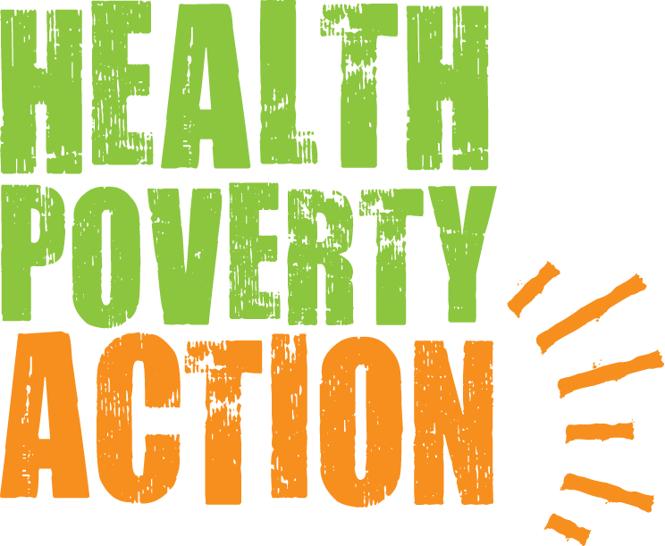

Job Title: Fundraising Intern

Job purpose: To support the effective functioning of the fundraising team

Responsible to: Head of Fundraising

Salary: £15,375 annually

Hours: Full-time preferred, part-time considered

Contract: August through December 2019

Closing date: 9am Wednesday 17th July 2019 (applications will be reviewed
throughout the posting period)

Interview dates: Week commencing 22nd July 2019

Please send your application form to: personnel@healthpovertyaction.org

Please note that due to a potentially high number of applications, only shortlisted
candidates will be notified.

BACKGROUND
Health Poverty Action acts in solidarity with health workers, activists and communities worldwide to improve health and challenge the causes of poverty.
Our distinct approach can be summarised as a combination of three features:
- We approach health as an issue of social justice
Health is a human right that many are currently denied. The greatest causes of poor health worldwide are political, social and economic injustices. This is a global scandal which causes unnecessary suffering on a massive scale.
We tackle these complex root causes of social injustice in two ways. Firstly, we work in partnership with communities to help them take back the power to improve their own health. Secondly, we campaign on a national and international level to change policy, and destroy unjust power relations.
- We prioritise those missed out by others
We believe in health for all, without exclusion. Development organisations tend to cluster together, which leaves large populations with almost no support at all. People may be living in hard to reach areas, or are difficult to support for some other reason. We make these most neglected populations our highest priority.
• We address the full range of factors which impact on health
Health is a combination of physical, mental and social wellbeing. As well as strengthening health services we work on areas such as nutrition, water, sanitation, gender discrimination, and income generation. Tackling one cause of poor health in isolation can give the appearance of improving health in the short term, but tackling numerous factors together saves lives.
We are acutely aware of how our own power dynamics as an organisation impact on the people we work with, and we work in partnership with communities to create long term relationships built on trust.
In 2017 we formed a strategic partnership with Find Your Feet. The partnership ensures Find Your Feet’s livelihoods work will continue through Health Poverty Action.
We are part of a global movement for health justice – the People’s Health Movement (PHM). The PHM is today’s embodiment of the primary health care movement and the radical vision it set out continues to rally health workers and policy makers worldwide. This quote from the founding document of this movement, the People’s Health Charter, sums up the essence of Health Poverty Action’s values and identity:
“Health is a social, economic and political issues and above all a fundamental human right. Inequality, poverty, exploitation, violence and injustice are at the root of ill-health and the deaths of poor and marginalised people. Health for all means that powerful vested interests have to be challenged, and that political and economic priorities have to be drastically changed. This Charter encourages people to develop their own solutions, and to hold accountable local authorities, national governments, international organisations and corporations.”

JOB DESCRIPTION

Context of the role

Health Poverty Action has an exciting portfolio of fundraising campaigns, which has grown as a result of our new partnership with Find Your Feet. We are ready to grow these campaigns, as well as develop new initiatives to take our unrestricted fundraising to the next level.

This internship presents a unique opportunity to learn about the work of two progressive international development NGOs and gain exposure to the whole fundraising team. This will serve as an excellent introduction if you’re keen to get into the sector.

You will increase capacity in the team to help grow our Community and Events campaigns and initiatives. This includes supporting our increasingly successful Curry for Change campaign, school initiatives, connections with religious groups and festive fundraising (carols, concerts and all things merry!).

You will also support the fundraising team more generally, as needed. You will have a key role in supporting a large match-funded public appeal this Autumn. You may also work on digital acquisition campaigns, aid on supporter communications and social media, help with the planning of corporate and major donor events, and much more!

You will develop strong fundraising skills through interaction with colleagues and supporters, and gain valuable experience of multi-tasking in a busy office environment.

Key responsibilities

The following outline provides a view of the scope of the work, within which your strategies and priorities will be agreed with the Head of Fundraising and Community and Events Officer.

• Provide key support to a large match-funded public appeal

• Support the Community and Events Officer to manage our festive fundraising, including coordinating with TFL and our choirs for carol singing slots, and supporting our choirs with concerts.

• Work to ensure the success of our key school fundraising initiatives – School Stomp and Health Heroes – including taking school presentations.

• Research and identify the most suitable faith groups to generate new community fundraising income (i.e. churches, mosques, other faith groups). Working with them to ensure they raise as much sponsorship as possible, with initial and ongoing supporter care.

• Help us deliver our annual Curry for Change October campaign, building its profile and the scope of events which help us deliver the campaign and achieve its fundraising targets.

• Provide help to develop and arrange profitable one-off events.

• Promote fundraising events by writing news releases and blog posts.

• Support logistics of our digital acquisition campaigns.

• Work alongside the fundraising and communications teams to identify and schedule content for social media across all our platforms, including Facebook and Twitter.

• Administrative and logistical support of the fundraising team, including cash handling.

• Act as a representative of Health Poverty Action and Find Your Feet when required and communicate its work in a passionate and professional way.

• Manage own workload and set objectives and deadlines with the Head of Fundraising and Community and Events Officer.

• Undertake all other reasonable activity requested by the organisation.

Safeguarding

This position will involve interacting with children through school carol singing, school concerts and school assemblies.

Health Poverty Action recognises that all adults and children have equal rights to protection from abuse and exploitation. Health Poverty Action condemns exploitation and inappropriate behaviour, and is committed to taking action for the protection of programme participants. In cases where positions include a high level of safeguarding risk, police checks or local equivalents will be carried out.

PERSON SPECIFICATION

Experience

- A successful track record that demonstrates outstanding qualities in the key areas
- Fundraising experience an advantage, though not a requirement

Key Areas

- Knowledge or experience of fundraising across multiple channels
- Understanding of the importance of raising our profile with new audiences
- Engaging, creative and effective communicator with excellent written and verbal communication skills
- Ability to think logically and solve problems
- Excellent attention to detail
- A successful track record of working to and meeting targets
- IT literate with excellent knowledge of Microsoft Office (especially Excel and PowerPoint)

Working Style

- A warm, friendly and empathetic colleague
- Valuable and positive cross-organisational team player who supports and motivates colleagues
- Able to work well both individually and as part of a team
- Enthusiasm and flexibility to take on new tasks
- Willingness to take responsibility and initiative
- Excellent negotiation and diplomacy skills, with the ability to find ways of getting things done cross-organisationally
- Able to work fast, contributing to a friendly, inclusive and supportive environment of energy, enthusiasm and collective success
- Well organised and reliable, with exceptional attention to detail and accuracy

General

- Ability to think and plan strategically, both creatively and laterally
- Can work flexibly, solve problems, and adapt to rapidly changing demands and opportunities whilst retaining clear priorities and strategic focus
- Proactive and self-motivated, with ability to use own initiative
- Ability to handle pressure and tight timescales, meeting and monitoring deadlines and targets
- Can work in a multi-cultural context

Commitment

- Passionate and demonstrable commitment to Health Poverty Action’s values
- Ability to enthuse and inspire others to support Health Poverty Action’s work

TERMS AND CONDITIONS

Salary

£15,375 annually

Hours

35 hours per week. Evening work in December will regularly be required, for which time off in lieu can be taken. Health Poverty Action believes in supporting flexible working as much as it reasonably can. We will consider applicants to work on a part-time and a flexible working basis where possible.

Location

The post is based at Health Poverty Action’s offices in Vauxhall (central London). Candidates will therefore need to either have or be able to acquire the right to work in the UK. The post will involve some travel in and around Greater London.

At Health Poverty Action we celebrate diversity and promote equality and inclusion amongst all of our staff and everyone we work with. We actively support and encourage people from a variety of backgrounds, experiences and skill sets to join us and help shape what we do. We are particularly keen to hear from ethnic minority candidates.

Thank you for considering working with Health Poverty Action.

