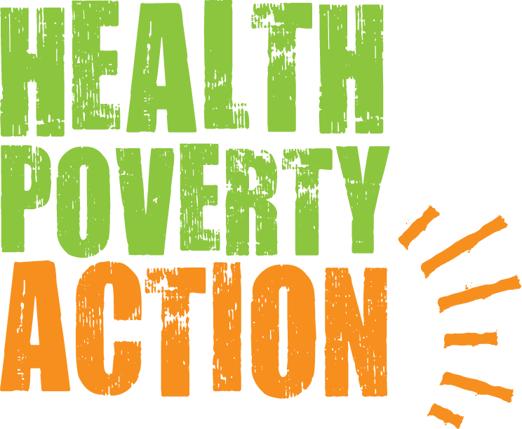

Job Title: Programme Intern

Responsible to: Programme Officer

Location: Vauxhall, London, UK – Right to work in UK a requirement (currently remote working)

Job purpose: To support the Programme Officer in the management of Health Poverty Action and Find Your Feet's Africa programmes by assisting in the administration of institutional grant projects including reporting, project finances and supporting country teams. Additional responsibilities will include supporting grant management; researching funding opportunities and good practices; assisting with proposal writing; and providing information, logistical and administrative services to international programme staff.

Salary: £19,201

Hours: Full-Time

Closing date: Sunday 8th November, 11.59pm

Interview dates: provisionally 17th/18th November

Please send your application form to: personnel@healthpovertyaction.org

Please note that due to a potentially high number of applications, only shortlisted candidates will be notified.

BACKGROUND

Health Poverty Action works for health and global justice in partnership with people who have been marginalised and pushed into poverty.

We work with communities to help them demand their right to health, and to challenge the power imbalances that deny them their health rights. Our distinct approach can be summarised as a combination of three areas:

- We approach health as an issue of social justice
Health is a Human Right that many are currently denied. The greatest causes of poor health worldwide are political, social and economic injustices. This is a global scandal which causes unnecessary suffering on a massive scale.

We tackle these complex root causes of social injustice in two ways. Firstly, we work in partnership with communities to help them take back the power to improve their own health. Secondly, we campaign on a national and international level to change policy, and destroy unjust power relations.

- We prioritise those missed out by others
We believe in health for all, without exclusion. Development organisations tend to cluster together, which leaves large populations with almost no support at all. People may be living in hard to reach areas, or are difficult to support for some other reason. We make these most neglected populations our highest priority.

- We address the full range of factors which impact on health
Health is a combination of physical, mental and social wellbeing. As well as strengthening health services we work on areas such as nutrition, water, sanitation, gender discrimination, and income generation. Tackling one cause of poor health in isolation can give the appearance of improving health in the short term, but tackling numerous factors together saves lives.

We are acutely aware of how our own power dynamics as an organisation impact on the people we work with, and we work in partnership with communities to create long term relationships built on trust.

In 2017 we formed a strategic partnership with Find Your Feet. The partnership ensures Find Your Feet’s livelihoods work will continue through Health Poverty Action.

We are also proud to be one of the small number of organisation recognised as being structurally part of the global People’s Health Movement. This quote from the founding document of this movement, the People’s Health Charter, sums up the essence of Health Poverty Action’s values and identity:

“Health is a social, economic and political issues and above all a fundamental human right. Inequality, poverty, exploitation, violence and injustice are at the root of ill-health and the deaths of poor and marginalised people. Health for all means that powerful vested interests have to be challenged, and that political and economic priorities have to be drastically changed. This Charter encourages people to develop their own solutions, and to hold accountable local authorities, national governments, international organisations and corporations.”

JOB DESCRIPTION

Context of the role

This position will sit within the Africa Programmes Team. Our programmes are managed by Country Directors overseen by two Heads of Programmes (one responsible for Africa and one responsible for Asia). The Programme Team in London provides support services to the development, implementation and administration of Health Poverty Action’s programmes. Health Poverty Action’s programme work in Africa takes place through country offices in Ethiopia, Kenya, Namibia, Rwanda, Sierra Leone and Somaliland and Find Your Feet’s in Malawi and Zimbabwe. The Programmes Department liaises with: the Policy & Campaigns Department to ensure strong integration between our programmes and advocacy work; the Fundraising Department to develop proposals and reports for trusts and foundations; and the Finance Department on programme finances.

Responsibilities

Main Functions of the Post

- To assist in the administration of project finances
- To assist with project logistics and grant management
- To assist in the broader administration of the Programmes Department
- To contribute to programme development

Outline of Responsibilities

1. To assist in the administration of project finances 40%
1.1 Assist in the preparation and maintenance of project budgets
1.2 Assist in monitoring field expenditure/income on allocated projects, providing feedback to field staff and the Programme Officer as appropriate
1.3 Assist in reviewing monthly financial reports, including bank reconciliations
1.4 Assisting in preparation of donor reports and claims together with Finance Department and the Programme Officer
1.5 Assist in monitoring cash flow to field offices and processing transfer requests

2. To assist with project logistics and procurement, support grant management & donor relations 40%
2.1 Assistance in procurement process in ensuring adherence internal and donor processes and procedures
2.2 Help to review quarterly and annual narrative reports from projects, and provide feedback
2.3 Provide administrative and logistical support to the Country Office staff and their consultants
2.4 Assist with the administration of evaluations (e.g. reviewing TORs, reviewing report drafts etc.)
2.5 Support the Programme Officer in monitoring donor relations & communications
2.6 Organise, analyse, and share donor feedback with other staff members and act as link between other London staff and field teams when required

3. Provide administrative support to the Programmes Team 5%
3.1 Organise filing for Africa projects, and ensure that both electronic and hard copy files are maintained within an agreed system, to allow easy access by other staff
3.2 Support integration of programme records and files into a database platform such as Sales Force
3.3 Provide other administrative support to the Programmes Team as required

4. To assist with programme development & research 15%
4.1 Provide support to proposal development and review draft proposals – including budgets
4.2 Support the small number of consultancies the Programme Team supports, including budgeting, bid development and review
4.3 Research best practices and innovative approaches that could be considered within our programmes

Safeguarding

This position may involve travel to overseas programmes and therefore may come into contact with vulnerable children and adults.

Health Poverty Action recognises that all adults and children have equal rights to protection from abuse and exploitation. Health Poverty Action condemns exploitation and inappropriate behaviour, and is committed to taking action for the protection of programme participants. In cases where positions include a high level of safeguarding risk, police checks or local equivalents will be carried out.

PERSON SPECIFICATION

Essential Criteria

- Bachelors degree in a relevant discipline
- A high level of numeracy & good analytical ability
- Excellent writing and editing skills
- Basic understanding of accounting and financial controls
- Experience of setting up spreadsheets and understanding of spreadsheet design using Excel
- Experience working/volunteering in a development NGO either at HQ or country office level
- Good organisational skills and the ability to juggle different demands and priorities
- Excellent word processing and Internet skills
- Experience of working in a fast-paced environment
- Openness to learning new skills & a pro-active approach to tasks
- Positive team-worker, supportive and helpful towards colleagues

Safeguarding

This position may involve travel to overseas programmes and therefore may come into contact with vulnerable children and adults.

Desirable Criteria

- Masters degree in a relevant discipline
- Experience in procurement processes for high value purchases
- Experience of managing & reporting against donor budgets
- Proven contract/grant management skills, including in the context of an overseas development or aid organisation & experience of the project cycle
- Experience in database set up, such as Sales Force
- Proven skills in preparing funding applications and reports to statutory donors
- Experience of institutional grant funders such as DFID, EC, Comic Relief, UN etc. funding proposals and reports (financial and programmatic)
- Ability to communicate with people from other cultures at a distance
- Experience of living and/or working in a developing country

TERMS AND CONDITIONS

Salary

£19,201

Hours

Full-time – 35 hours per week for 6 months initially with potential to extend (part-time basis will be considered)

Health Poverty Action is very committed to flexible working. We will consider applicants to work on a part-time and a flexible working basis where possible.

Holidays

25 working days holiday a year

Pension

Staff are encouraged to join Health Poverty Action’s pension scheme. Health Poverty Action will match your contributions up to a maximum of 5% of gross salary.

Location

The post is based at Health Poverty Action’s offices in Vauxhall (central London). Candidates will therefore need to either have or be able to acquire the right to work in the UK. The post may involve some international travel. Currently due to Covid-19 this post-holder will be working remotely.

At Health Poverty Action we celebrate diversity and promote equality and inclusion amongst all of our staff and everyone we work with.

Health Poverty Action recognises that all adults and children have equal rights to protection from abuse and exploitation. Health Poverty Action condemns exploitation and inappropriate behaviour, and is committed to taking action for the protection of programme participants. In cases where positions include a high level of safeguarding risk, police checks or local equivalents will be carried out.

Thank you for considering working with Health Poverty Action.

