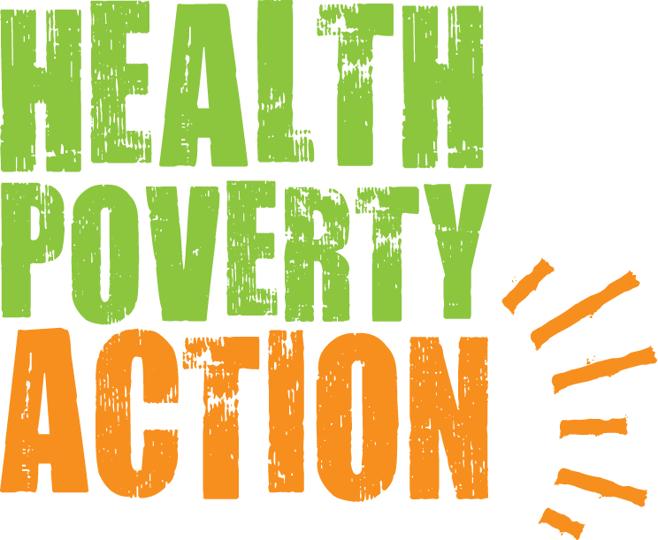

Job Title: Executive Assistant to CEO and Communications

Job purpose: Provide general assistance to the CEO, senior managers and the work of their departments.
Contribute to Health Poverty Action’s communications.

Salary: £22,874 rising in length of service increments to £26,803

Hours: Full Time 35 hours. Flexible options considered.

Location: Home-based.
Part of the organisation’s Core Team (formerly based in London and called Head Office, now increasingly internationalised)

Responsible to: CEO

Closing date: 9.00am UK time, Mon 9 May

Interview dates: Mon 16 May and Tues 17 May

Please send your application form to: personnel@healthpovertyaction.org

Due to a potentially high number of applications, we ask for your understanding that only shortlisted candidates will be notified.

Thank you for your interest in the work of Health Poverty Action.

Health Poverty Action’s work and values

Health Poverty Action (HPA) is a medium sized INGO, acting in solidarity with poor and marginalised communities in their struggle for health and social justice.

We currently have programmes in 15 countries, and around 400 staff worldwide. Our head office team (historically based in London) is currently home-based, in increasingly diverse geographical locations around the world.

Within what is a broad spectrum of organisations working on issues of global poverty, we aim to be a politically progressive voice and influence.

Importantly, we are rooted in a global movement – the People’s Health Movement (PHM) – which achieved ground-breaking influence through the UN Conference on Primary Health Care at Alma-Ata in 1978. Such was the power of that moment, that 40 years later its radical vision continues to rally health workers, policy makers and activists worldwide.

These words (from the ‘People’s Charter for Health’), sum up Health Poverty Action’s ethos:

“Health is a social, economic and political issue and above all a fundamental human right. Inequality, poverty, exploitation, violence and injustice are at the root of ill-health and the deaths of poor and marginalised people. Health for all means that powerful vested interests have to be challenged, and that political and that economic priorities have to be drastically changed. This Charter encourages people to develop their own solutions, and to hold accountable local authorities, national governments, international organisations and corporations.”

This is the call we take up together as an organisation – working with poor and marginalised communities around the world to develop and implement locally and culturally-appropriate solutions, and to challenge the injustices that currently deny life and health to so many.

Country programmes include: improving health systems and disease control, maternal and child health, mental health, food security and nutrition, water and sanitation, gender justice and eradicating harmful practices (such as FGM), and income generation and social enterprise.

Alongside these, we lobby and campaign to change the unjust policies and practices that force people into poverty and destroy their health, and tackle the powerful vested interests that sustain them.

We recognise these are often rooted in colonialism and imperialism (both historical and ongoing), and have strong racial and gender dimensions.

Our work includes issues that many organisations have felt to be too controversial, such as campaigning for drug policy reform to address the harms caused by the War on Drugs.

These are big challenges to take on, and the obstacles to change are many. But we passionately believe in the revolutionary idea that health and social justice can prevail against them. We know with absolute certainty that big and powerful change is possible – because we’ve seen it so many times in our work, and in such inspiring ways.

Every day, through our work together, we have the incredibly exciting opportunity to do something that will help bring more of this about.

If this sounds like something you would like to be part of, we would love to hear from you.

JOB DESCRIPTION

Context of this role

This is a unique role, which might provide a great entry point to the global justice/development sector for someone of outstanding ability who would like to work in it over the longer term.

While the duties are often of an administrative nature (which can also be challenging and varied), the role’s cross-organisational nature, and its working relationships with senior staff, serve as an excellent introduction to the various types of work in a significant global justice organisation.

There are possibilities, over time, of the post holder gradually learning and developing in different areas of work relevant to their skill set and personal interests, whether that be policy/campaigns, fundraising, programmes, or administrative/finance functions.

However this is far more than a role in which to develop for the future. It is one in which the right person can make a profoundly valuable contribution to the life and work of Health Poverty Action right now. It fulfils some key organisational functions. Having these performed well – by someone who shares our passion for global justice – makes such a difference, benefiting all aspects of our work around the world.

Key responsibilities

The following summary is indicative of the current scope of the role. However we recognise that the continually developing nature of our work means it is not possible to have fixed responsibilities, and we also wish to support personal development wherever possible.

Health Poverty Action therefore allows for responsibilities attached to posts to be continually reviewed and adjusted in consultation with the post holder, considering the developing needs of both the organisation and the individual.

- Support to CEO and senior managers

  - Provide general administrative and other assistance to the CEO
  - Provide general administrative and other assistance to the Senior Management Team and the work of their departments:
Africa Programmes
Asia Programmes
Policy & Campaigns
Fundraising
Finance & Administration

- Communications

  - Contribute to Health Poverty Action’s communications, especially in support of our Fundraising and Policy & Campaigns work, including for example:
- creating content for our website, keeping it up to date, and reviewing analytic reports of visits to increase usage
- sending out tweets and monitoring our Twitter account
- supporting other aspects of our social media presence and wider media profile
- contribute to organisational publications such as our annual report

- Organisational administration

  - Provide administrative support to Board meetings and the work of trustees, including:
- attending and minuting meetings as required, including our quarterly board meetings and occasional subcommittee
- booking rooms/refreshments and preparing meeting logistics (eg facilities for Zoom participation)
- preparing, collating and sending out board papers
- Support with organisational responses to requirements of regulatory bodies, such as the Charity Commission and Companies House, and inform them of changes in the membership of our Board of Trustees
- Support managers as required in the development and roll out of new or revised organisational policies

- Human Resources

    - Maintain secure files of staff and trustee records (such as employment contracts, leave records, and contact details)
    - Ensure strict confidentiality and security of personal information
    - Assist with induction of new ‘head office’ staff to systems, procedures and our virtual office environment (and make the necessary arrangements, such as closing their IT accounts, when staff leave)
    - Maintain files of current organisational HR policies (such as parental leave, and disciplinary/grievance procedures)
    - Support senior managers in their ‘head office’ staff recruitment processes, eg by posting job advertisements and collating applications for them to review

- Maintenance of ‘head office’ work environment

- Monitor and respond to as needed (eg by forwarding to the relevant person) any incoming messages from our publicly available phone number and email
- Address any issues that might arise to ensure the smooth functioning of our virtual ‘head office’ work environment, such as liaising with the companies receiving and forwarding our mail, and storing our hard copy records

Safeguarding

Health Poverty Action believes all adults and children have equal rights to protection from abuse and exploitation. We are committed to taking action for the protection of all participating in and related to our work, and to eliminate exploitative and inappropriate behaviour. In cases where positions include a high level of safeguarding risk, police checks or local equivalents will be carried out.
PERSON SPECIFICATION

Qualifications and experience

Academic and/or experience to demonstrate a strong general intelligence, combined with good awareness of practicalities

Knowledge and skills

Fast learner, capable of understanding and implementing new systems quickly

Highly effective communicator; engaging writer

Excellent organisational skills, able to adapt to new challenges as they arise

Reliable, able to meet deadlines

Working style

Pro-active, practical and energetic. Someone who takes responsibility and delivers

Good at working under pressure and to tight deadlines, and able to deal with variable workload and additional requests

Flexibility and willingness to take on new tasks when required

Well-organised, with excellent attention to detail

Resourceful, able to deliver with limited resources

Excellent team player – a positive, supportive and collaborative colleague

Personal

Flexible and adaptable

Approachable, empathetic and supportive personality

Able to work effectively in a multi-cultural context

Able to maintain confidentiality

Proximity to physically attend occasional meetings in London, eg Board meetings, is a slight advantage (but this is not a major factor – the post can be located anywhere)

Commitment

Passionate commitment to Health Poverty Action’s work and values
TERMS AND CONDITIONS

Salary

£22,874 rising in length of service increments to £26,803

Hours

35 hours per week.

It is possible that on occasions some work in unsocial hours may be required, for which time off in lieu is available.

Health Poverty Action believes in supporting flexible working as much as it reasonably can.

Holidays

25 days per year, plus the time between Christmas and New Year, plus eligible public holidays.

An additional day leave is added for each two years completed service, up to a maximum of 3 days.

Pension

Staff are encouraged to join Health Poverty Action’s pension scheme. Health Poverty Action will match your contributions up to a maximum of 5% of gross salary (and subject to a minimum contribution of 4%).

Location

This is a home-based post. It can be located anywhere with good enough internet.
It is part of Health Poverty Action’s Core Team.
This team was previously based in a London office, and at that time known as our ‘Head Office team’, but has now moved to home working, enabling much more diversity of location.
Some occasional London-based practicalities that remain, which means that having proximity to occasionally attend meetings there in person is a very slight advantage, but this will not be a major factor in recruitment.

At Health Poverty Action we celebrate diversity and promote equality and inclusion amongst all of our staff and everyone we work with.

Thank you for considering working with Health Poverty Action.

