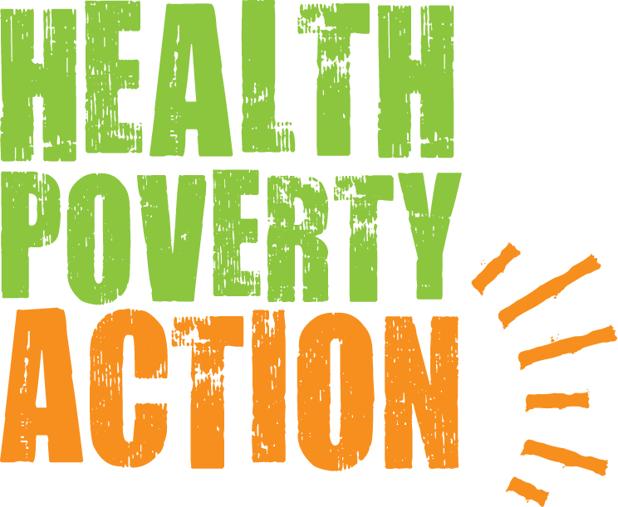

**Job Title: New Business Development Officer**

**Responsible to:** Head of Programmes Asia

**Job purpose:** To help grow unrestricted and restricted income for Health Poverty Action through emerging donor and new business approaches.

**Salary:** £28,000 to £36,000 per annum, depending on experience.

**Hours:** Full-time, 35 hours per week (part-time possible)

**Closing date:** Wednesday, 20th August 2025 at 11:59 PM BST  
  
**Please send** [**your application**](http://www.healthpovertyaction.org/wp-content/uploads/2025/08/HPA-Application-Form-August-2025.docx) **form as a PDF file to:** [**personnel@healthpovertyaction.org**](mailto:personnel@healthpovertyaction.org)

*Please note that due to a potentially high number of applications, only shortlisted candidates will be notified.*

Thank you for your interest in Health Poverty Action’s work.

**—————————————————————————————————————**

**Health Poverty Action’s work and values**

Health Poverty Action (HPA) is a medium-sized INGO, acting in solidarity with poor and marginalised communities in their struggle for health and social justice.

Health Poverty Action works in 10 countries across Africa, Asia and Latin America. We always prioritise the poorest and the most marginalised – those neglected by governments and almost everyone else. This has led us to work in some very difficult environments, often providing the only external assistance. Health Poverty Action currently employs about 300 staff worldwide (with the vast majority located in our programme countries).

In the current political context, traditional institutional international development funding has reduced dramatically, almost overnight. This downward trend is expected to continue over the next few years. The few funding opportunities are extremely competitive. New sources of funding from emerging donors and new business approaches need to be taken to sustain our operations, not only at the country level, but also our core costs organisation wide.

Within what is a broad spectrum of organisations working on issues of global poverty, we aim to be a politically progressive voice and influence.

Importantly, we are rooted in a global movement – the People’s Health Movement (PHM) – which achieved ground-breaking influence through the UN Conference on Primary Health Care at Alma-Ata in 1978. Such was the power of that moment that 40 years later its radical vision continues to rally health workers, policy makers and activists worldwide.

These words (from the ‘People’s Charter for Health’) sum up Health Poverty Action’s ethos:

*“Health is a social, economic and political issue and above all a fundamental human right. Inequality, poverty, exploitation, violence and injustice are at the root of ill-health and the deaths of poor and marginalised people. Health for all means that powerful vested interests have to be challenged, and that political and that economic priorities have to be drastically changed. This Charter encourages people to develop their own solutions, and to hold accountable local authorities, national governments, international organisations and corporations.”*

This is the call we take up together as an organisation – working with poor and marginalised communities around the world to develop and implement locally and culturally-appropriate solutions, and to challenge the injustices that currently deny life and health to so many.

Country programmes include: improving health systems and disease control, maternal and child health, mental health, food security and nutrition, water and sanitation, gender justice and eradicating harmful practices (such as FGM), and income generation and social enterprise.

Alongside these, we lobby and campaign to change the unjust policies and practices that force people into poverty and destroy their health — and tackle the powerful vested interests that sustain them.

We recognise these are often rooted in colonialism and imperialism (both historical and ongoing) and have strong racial and gender dimensions.

Our work includes issues that many organisations have felt to be too controversial, such as campaigning for drug policy reform to address the harms caused by the War on Drugs, harms disproportionately felt by the most marginalised populations.

These are big challenges to take on, and the obstacles to change are many. But we passionately believe in the revolutionary idea that health and social justice can prevail against them. We know with absolute certainty that big and powerful change is possible – because we’ve seen it so many times in our work, and in such inspiring ways.

Every day, through our work together, we have the incredibly exciting opportunity to do something that will help bring more of this about. If this sounds like something you would like to be part of, we would love to hear from you.

In 2017, we formed a strategic partnership with Find Your Feet. The partnership ensures Find Your Feet’s livelihood work will continue through Health Poverty Action. In 2022, the Health Poverty Action family grew to include a US-based 501c3 organisation – Health Poverty Action USA – with whom we are also a strategic partner.

**JOB DESCRIPTION**

**Job purpose**

To support Health Poverty Action to develop and implement strategies to diversify our funding sources both in HPA programme countries in Asia and in the UK, and develop this capacity among regional and country teams in Asia to do so.

Your main task will be identifying new donors in programme countries and the UK, including government, private individuals and businesses, and to explore possibilities of social enterprise to generate income through partnership with businesses, or setting up our subsidiary social enterprises as well as in the UK.

This is an important leadership role to support country teams as part of the HPA Asia programme team in managing existing donor contracts and relationships, identifying new funding opportunities, designing and developing programmes.

**Key responsibilities**

In the continually changing environment in which we operate, it is not possible to have fixed responsibilities, and this presents an exciting opportunity to shape this role yourself. The following outline provides a view of the scope of the work, within which your strategies and priorities will be agreed with the Head of Programmes Asia.

**New Business and Programme Development (60%)**

* Explore partnerships with emerging donor countries in Asia, focusing on the Chinese government and businesses, both public and private, particularly in the context of Health Poverty Action’s (HPA) social enterprise initiatives and the replication of successful models.
* Network with existing partners and donors across the Southeast Asia region. Where appropriate, negotiate partnerships and strategic alliances for programme development and implementation.
* Explore the potential for expanding HPA’s programme portfolio into new regions and countries in Asia.
* Maintain up-to-date knowledge of key funding trends and opportunities relevant to HPA’s work across Asia and support the development of institutional donor proposals in collaboration with the Head of Programme Asia, and country teams.
* Continuously identifying opportunities for proposal submissions and strategic partnerships with donors, including institutional funders, international and national NGOs, public and private sector actors, corporations, humanitarian agencies, and academic and research institutions.
* Liaise with fundraising colleagues to enhance contributions from existing fundraising activities in the UK and US.

**Donor Relations and Organisational Representation (20%)**

* Represent Health Poverty Action at donor and partner meetings, as well as at relevant external events and networking opportunities.
* Handle donor enquiries and maintain positive, professional relationships with funding partners.
* Support the organisation’s visibility and reputation with key stakeholders through strong representation and consistent engagement.

**Programme Support (20%)**

* Assist country teams with the timely and high-quality submission of donor reports, while strengthening their capacity to manage reporting processes independently.
* Provide support on contract management, donor compliance, reporting systems and procedures, and operational workplans at the country level.
* Support the design and administration of studies, evaluations, and research, including reviewing terms of reference and draft reports.
* Oversee the effective implementation of projects, ensuring that challenges identified through project delivery, monitoring, and evaluation are addressed, and lessons learned are integrated into future programming.
* Deliver training and capacity building for country teams on report writing and donor relationship management.
* Work with the Programme Quality Manager to develop and refine internal databases, tools, systems, and procedures to support effective project management, monitoring, evaluation, and learning (MEL).
* Undertake travel, as necessary, to monitor, evaluate, or support programme implementation and development.
* Ensure all programme files and documentation are properly maintained and accessible within the agreed systems.
* Collaborate with the Policy and Campaigns team to ensure programme insights contribute to wider advocacy efforts and policy influence, both nationally and globally.

**Other**

* Be aware of all Health Poverty Action work and developments, to identify stories and material for fundraising purposes.
* Act as a representative of Health Poverty Action when required and communicate its work passionately and professionally.
* Manage own workload and set objectives and deadlines with the Head of Programmes Asia.
* Undertake all other reasonable activities requested by the organisation.

**PERSON SPECIFICATION**

The following indicates the qualities we believe will provide a good fit, but not all suitable applicants will have all of these. If you would love to do the job and believe you can demonstrate abilities that will enable you to succeed in the position, we would love to hear from you.

***Essential criteria***

* Proficiency in Chinese would be a significant advantage.
* A master’s degree in development studies, Global Studies, Economic History, Business Management, or another relevant field.
* Demonstrated experience and skills in public relations, particularly government engagement in the regions where HPA operates.
* Solid understanding of how potential donors and partners work in HPA’s programme countries in Asia and the UK.
* Strong links with government and/or business in Asia, especially China, with clear strategy to develop partnerships with them both in Asia and the UK.
* Excellent English writing and editing skills, with the ability to produce clear, insightful, and persuasive content under tight deadlines.
* Outstanding organisational and time management abilities, including task delegation and managing personal and team workloads across multiple priorities.
* Proactive and open to learning new skills, with a hands-on approach to problem-solving.
* A collaborative, positive team player who is committed to supporting the capacity-building of regional and country teams in programme development.

***Desirable criteria***

* Strong numeracy skills and budget literacy. CFA, CPA, or ACCA certification (or candidacy) is highly desirable.
* Experienced in using social media tools, such as TikTok or Rednote.
* Previous experience of living and/or working in one of the HPA Asia programme countries.
* Willingness and ability to travel internationally.

***Working Style***

* A warm, friendly and empathetic colleague.
* Valuable and positive cross-organisational team player who supports and motivates colleagues.
* Able to work well both individually and as part of a team.
* Enthusiasm and flexibility to take on new tasks.
* Willingness to take responsibility and initiative.
* Excellent negotiation and diplomacy skills, with the ability to find ways of getting things done cross-organisationally.
* Able to work fast, contributing to a friendly, inclusive and supportive environment of energy, enthusiasm and collective success.
* Well organised and reliable, with exceptional attention to detail and accuracy.

***General***

* Ability to think and plan strategically, both creatively and laterally.
* Can work flexibly, solve problems, and adapt to rapidly changing demands, and   
  opportunities whilst retaining clear priorities and strategic focus.
* Proactive and self-motivated, with the ability to use own initiative.
* Ability to handle pressure and tight timescales, meeting and monitoring deadlines and targets.
* Appreciates working in a multi-cultural context.

***Commitment***

* Passionate and demonstrable commitment to Health Poverty Action’s values.
* Ability to enthuse and inspire others to support Health Poverty Action’s work.

*Health Poverty Action recognises that all adults and children have equal rights to protection from abuse and exploitation. Health Poverty Action condemns exploitation and inappropriate behaviour and is committed to taking action for the protection of programme participants. Accordingly, you will be responsible for: Protecting programme participants, staff and volunteers from any harm coming from our staff, operations and programmes; Reporting all safeguarding incidents you saw, heard, heard about or suspected, using our internal reporting procedure; Observing and fully complying with all organisational safeguarding policies and practices; signing the code of conduct and as appropriate complying with HR vetting procedures.*

**TERMS AND CONDITIONS**

**Salary**

£28,000 to £36,000 per annum, depending on experience.

**Hours**

Full time, 35 hours per week. Evening and weekend work may sometimes be required, for which time off in lieu can be taken. *We will consider applicants to work on a part-time and flexible working basis where possible.*

**Holidays**

25 days per year, plus the time between Christmas and New Year, plus English public holidays. An additional day of leave is added for each two years of completed service, up to a maximum of 3 days.

**Pension**

Staff are encouraged to join Health Poverty Action’s pension scheme. Health Poverty Action will match their own contributions up to a maximum of 5% of gross salary (and subject to a minimum contribution of 4%).

**Location**

Home-based within the UK, you should be able to attend occasional meetings and events in London. Part of the organisation’s Core Team (based in London/UK and internationally).

**Contract length**

This is a permanent position. The notification period for HPA due to organisational restructuring or other force majeure is 3 months minimum, and employees is 4 weeks.

***At Health Poverty Action, we celebrate diversity and promote equality and inclusion amongst all our staff and everyone we work with. We actively support and encourage people from a variety of backgrounds, experiences and skill sets to join us and help shape what we do. We are particularly keen to hear from ethnic minority candidates.***

*Thank you for considering working with Health Poverty Action.*

**TO APPLY**

Download and complete the application form. You can download it [here](http://www.healthpovertyaction.org/wp-content/uploads/2025/08/HPA-Application-Form-August-2025.docx).

Due to the potentially high number of applications, we ask for your understanding that only shortlisted candidates will be notified.

Please send your completed application form, in PDF format, to [personnel@healthpovertyaction.org](mailto:personnel@healthpovertyaction.org) by Wednesday, 20th August.

Thank you for completing the application form.

This helps ensure fairness and consistency and is also a demonstration of your interest in the role.

We know this takes time, and we promise that we will only consider applications from people who do so.

By completing the form, you are making a valuable contribution to Health Poverty Action's work - we really appreciate it.

At Health Poverty Action, we celebrate diversity and promote equality and inclusion amongst all of our staff and everyone we work with.

Thank you for considering working with us.